Ideation Phase

Brainstorm & Idea Prioritization Template

Date | 15 February 2026
Team ID | LTVIP2026TMIDS47425
Project Name | IntelliSQL: Intelligent SQL Querying with LLMs Using Gemini Pro
Maximum Marks | 4 Marks

Brainstorming in the IntelliSQL – Intelligent SQL Querying with LLMs Using Gemini Pro project creates a collaborative environment where team members freely explore innovative ways to improve natural language to SQL conversion, system performance, security, and user experience. By encouraging open discussion and prioritizing idea generation over immediate evaluation, the team can experiment with advanced prompt engineering strategies, better query validation mechanisms, smarter result visualization techniques, and performance optimizations. All ideas—whether incremental improvements or bold innovations—are welcomed, refined, and expanded collectively to design a more intelligent and efficient SQL querying system.
Use this structured brainstorming approach during IntelliSQL development meetings to identify challenges, generate enhancement ideas, and prioritize features for upcoming sprints. Even if the team is working remotely, this method helps organize creative thinking, align objectives, and transform innovative concepts into actionable development tasks that strengthen the overall system.

Step-1: Team Gathering, Collaboration and Select the Problem Statement

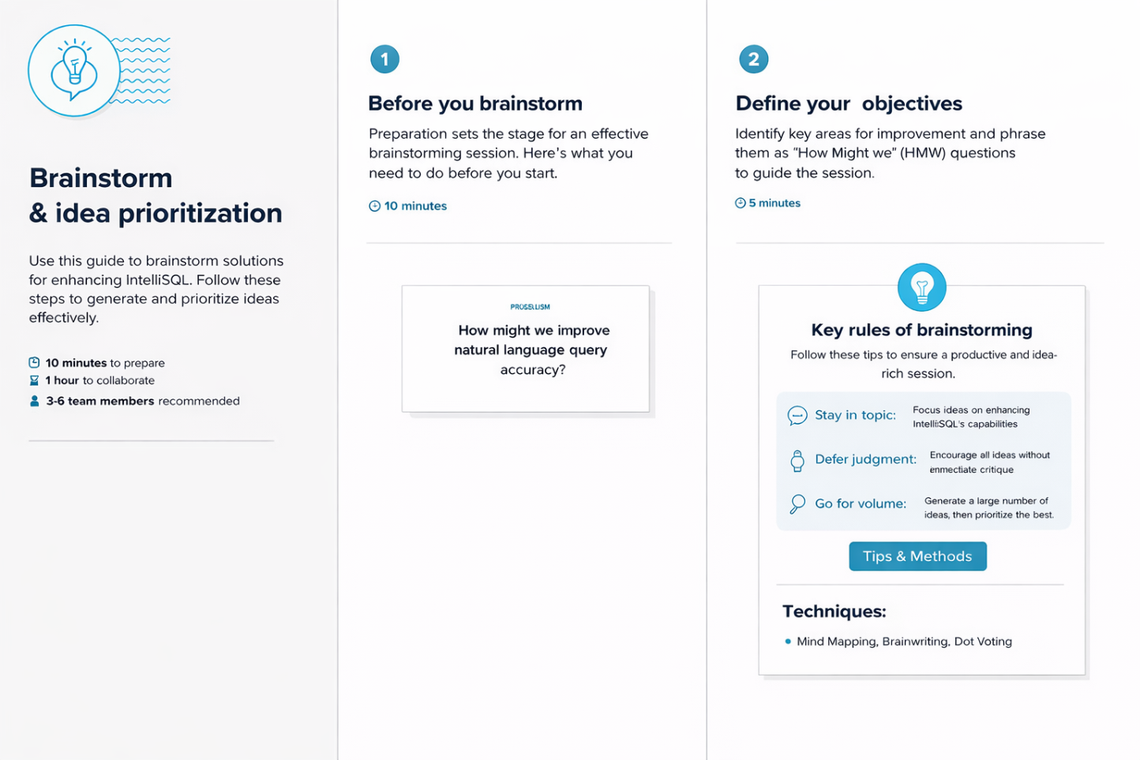

Step-2: Brainstorm, Idea Listing and Grouping

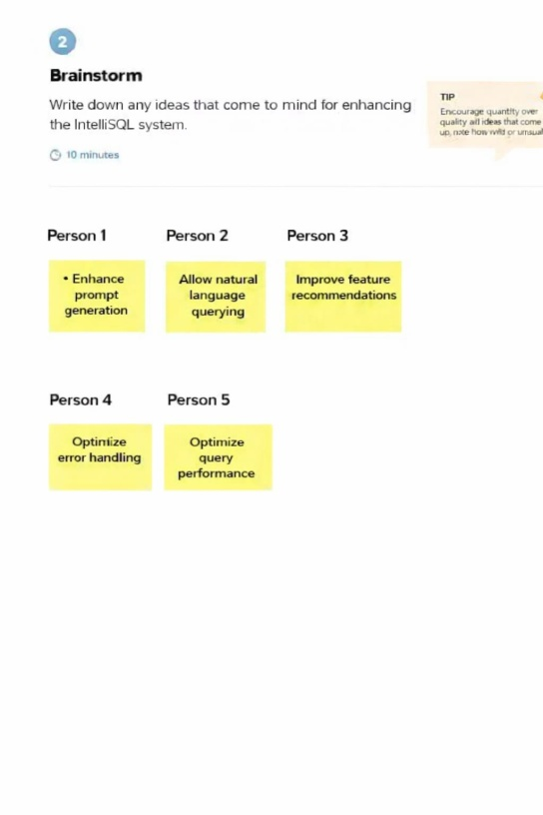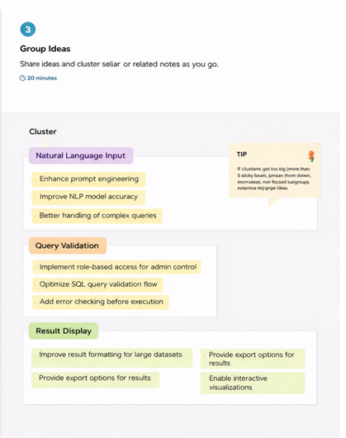

Step-3: Idea Prioritization

